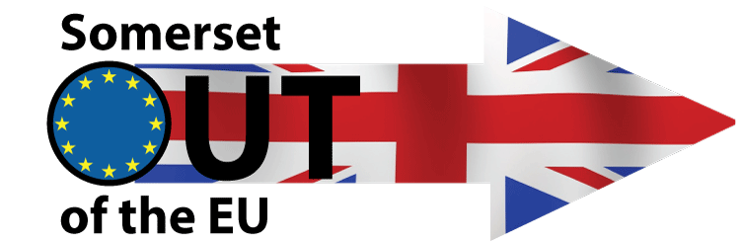
Campaign News
Report 4

Team 2 – Godfrey Davey chairman@soeu.co.uk
SOEU comes to Yeovil with Vote Leave on Saturday 7th May 2016
Yeovil 10 to 12.00
Another good day in Yeovil with a good turnout, plenty of leaflets distributed and an excellent response.

SOEU comes to Chard with Vote Leave on Saturday 14th May 2016
We held a table top in Chard on Saturday,- another joint venture with "Vote Leave" and "SOEU"which was very successful with a good level of support.it went very well and had a positive response.

Next stop Crewkerne on Saturday 21st May & Yeovil on Saturday 28th May
---------------------------------------------------------------------------------------------------------------------------
Team 3 – Stephen Fitzgerald stephen@soeu.co.uk
SOEU comes to Weston on Saturday 7th May 2016
Weston shopping centre 11am to 1pm
Another good turnout ! Nick Joined us from Wellington, Robert from Weston and a woman from GO as well as our usual team. Brian from Crowcombe also joined us. Many leaflets given out and a lot of support. A nearby couple of Remain people gave up after an hour and we found a nearby waste bin stuffed with their leaflets. Vote Leave were operating close by as well.
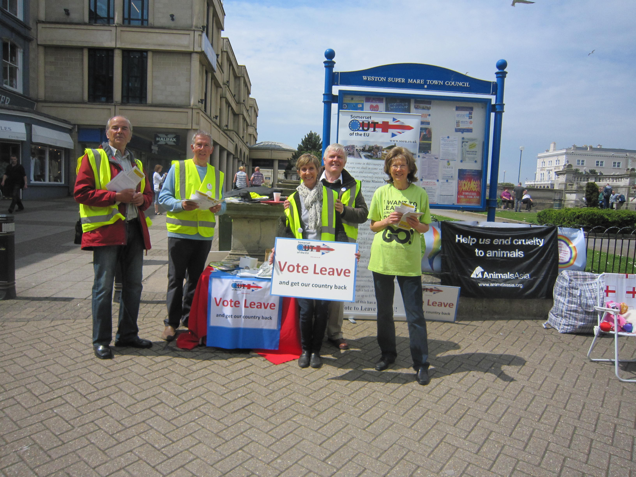
l-r Ivor Jones, Roger Kent, Val Kent, Stephen Fitzgerald, GO supporter
Robert, Brian Lloyd and Peter Barbuti out of picture

SOEU comes to Burnham Saturday 14th May
Burnham High Street 11am to 1pm
This was the best event yet. Excellent turnout with supporters from North Petherton, (Catherine ) Wellington ( Nick ) and Weston ( Robert) and our usual team. People were actually asking for our leaflets and many cars stopped requesting our leaflets. The level of support was the highest yet, possibly reaching 57%.
Spoke to a couple of Remain people – we educated one about the lack of democracy in the EU which he shrugged off by commenting that it did not worry him. We educated another one that it was Germany which dominated the EU. He commented that they made really good cars and he was quite happy about it. A German couple exchanged pleasantries with us indicating that it may not be long before they wanted a referendum as well.
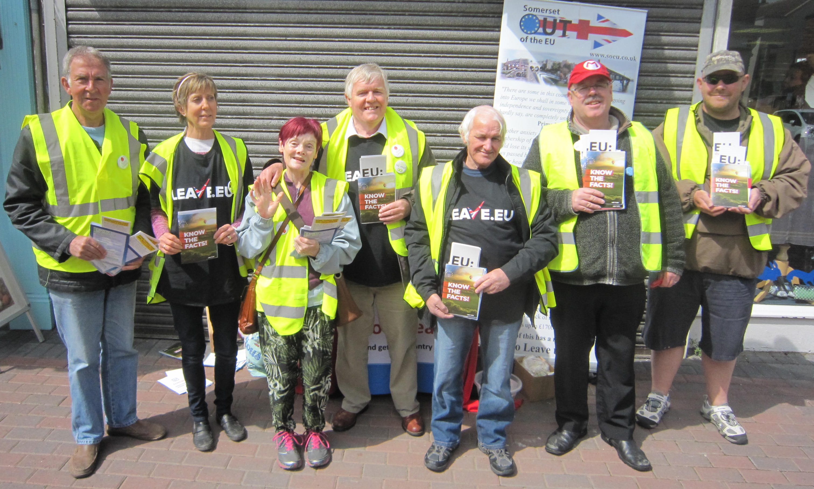

Roger, Val, Catherine, Stephen, Adrian, Robert, Nick
Next stop – Wellington on Saturday 21st May & Street & Glastonbury on Sat. 28th May

